**ROUTE53 Routing Policies**

* **Simple routing**

It is the most simple policy which can use a single IP address. It can be a web server which serves the requests for a particular domain. It is a basic policy with no rules

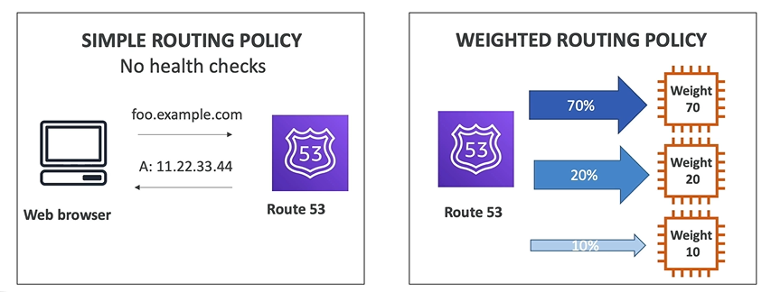

* **Latency based**

This policy can be used when we have servers in different regions and response is required with the lowest latency. So if two servers are in Australia and America, for e.g users accessing it from India will be served by Australian server since its latency is lowest for Indian users.

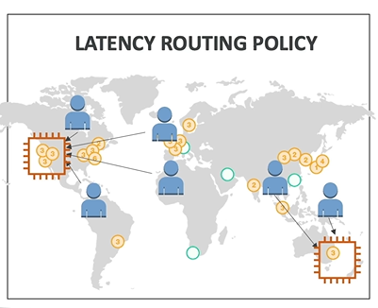

* **Geolocation based**

This policy lets the route53 to respond to queries according to the geographic location of the users. The location is traced via the IP address of the user. You can specify geographic locations by continent or by country.

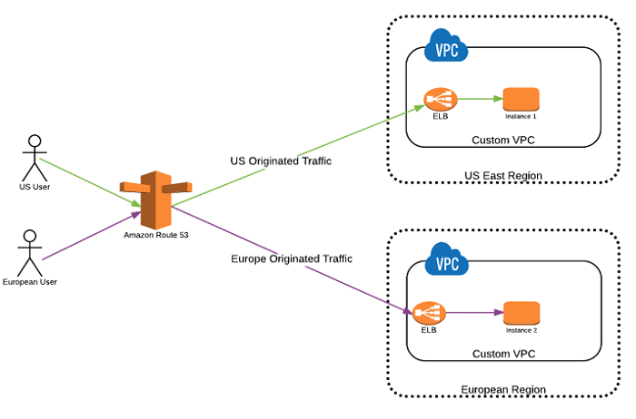

* **Failover routing**

This policy can be used when we have a primary server and a secondary backup server. Health checks are used to monitor the health of resource. Till the primary resource is healthy all traffic is send to it, and when primary server becomes unavailable, all traffic is send to secondary resource

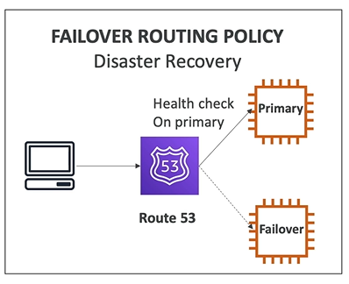

* **Weighted**

This policy enables us to route traffic to servers based on proportions or weight that we decided, for e.g 60% on one server and 40% on other server. A record is assigned a weight that corresponds how much traffic should be send to each server

Weight number can be anything between 0-255

Formula: Weight of a record / Sum of weights of all records

e.gmywebsite.com has three server record sets with weights of 1, 1 which is 20% each and 3 which is 60% and the total is 5. Route 53 selects each of the first two server record sets 1/5th of the time, and returns the third server record set 3/5th of the time.

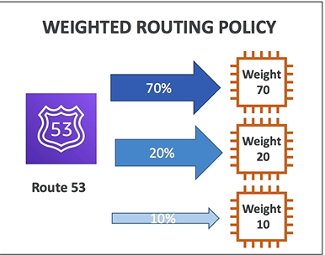

* **Multivalue answer routing**

This policy lets you to return multiple values like IP address for web servers. This also has health check, so we can return only those values whose servers are healthy. If any value becomes unhealthy then the client chooses another value

